Aim: Audio processing using Python
IDE:
Python is a powerful language for audio processing due to its simplicity and ease of use. It provides several libraries for audio processing, including soundfile, librosa, and Pydub, among others. we will explore how to use Python for audio processing and some of its practical applications.
Library Installation
pip install soundfile

Reading and Writing Audio Files:
The first step in audio processing is reading and writing audio files. In Python, we can use the soundfile library to read and write audio files in various formats, including WAV, FLAC, and MP3. Here’s an example of how to read an audio file using the soundfile library:
import soundfile as sf
# Load audio file
audio, sample_rate = sf.read('audio_file.wav')
Similarly, we can use the same library to write an audio file as follows:
import soundfile as sf
# Write audio file
sf.write('new_audio_file.wav', audio, sample_rate)
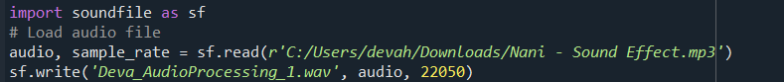
Output:

Original Sound File:
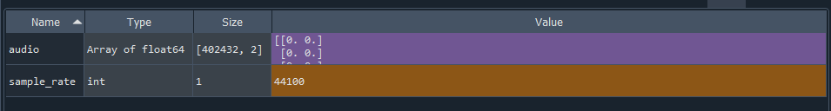
Sampled Sound File 1:
Audio Visualization:
Visualizing audio data is important for analyzing and understanding audio signals. In Python, we can use the matplotlib library to plot audio signals in the time domain or frequency domain. Here’s an example of how to plot an audio signal in the time domain:
import soundfile as sf

# Load audio file
audio, sample_rate = sf.read(r'C:\Users\Mitesh\OneDrive\Desktop\test.wav')

# Write audio file
sf.write('new_audio_file.wav', audio, sample_rate)
Output:
Sampled Sound File 2:
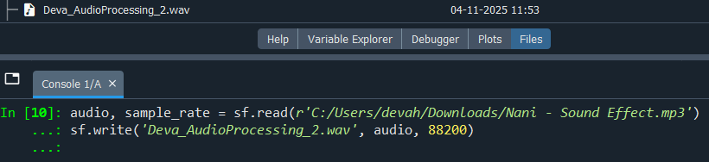
import matplotlib.pyplot as plt
import numpy as np
import soundfile as sf
# Load audio file
#audio, sample_rate = sf.read('audio_file.wav')
# Create time axis
time = np.arange(0, len(audio)) / sample_rate
# Plot audio signal
plt.plot(time, audio)
plt.xlabel('Time (s)')
plt.ylabel('Amplitude')
plt.show()
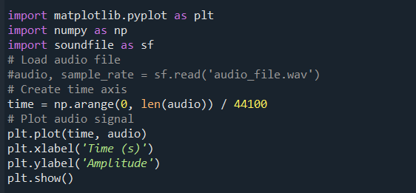
Output:
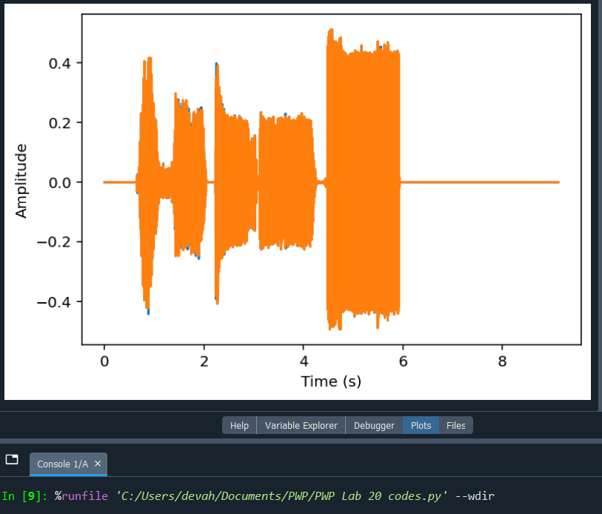
Audio Effects:
Python provides several libraries for adding audio effects to audio files. One such library is Pydub, which can be used to add effects such as fade in/out, change speed/pitch, and add equalization (EQ). Here’s an example of how to add a fade-in effect to an audio file using Pydub:
Installation
pip install pydub
rom pydub import AudioSegment
# Load audio file
audio = AudioSegment.from_file('audio_file.wav')
# Add fade in effect
audio_fade_in = audio.fade_in(2000) # 2 seconds
# Export audio file with fade in effect
audio_fade_in.export('audio_file_fade_in.wav', format='wav')

Reference Link: https://www.kaggle.com/code/vuppalaadithyasairam/audio-pre-processing-tutorial-in-python

GitHub:
https://github.com/vahchalya-bodas/vahchalya.git

